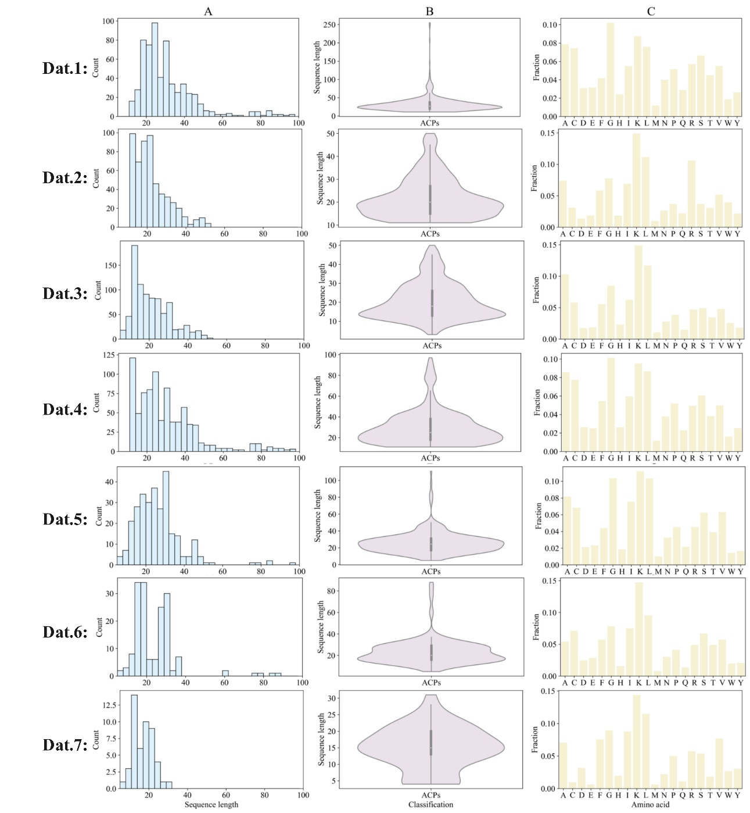

Figure S1 Statistics summary of the benchmark dataset. (A) Representation of the sequence length distribution through a histogram. (B) Visualization of the sequence length distribution using a violin plot. (C) Distribution of amino acids.

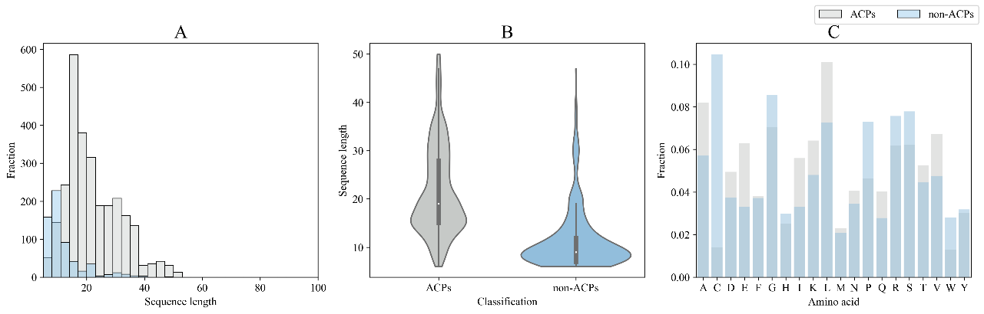

Figure S2 Statistics summary of the mACPpred 2.0 independent test dataset. (A) Representation of the sequence length distribution through a histogram. (B) Visualization of the sequence length distribution using a violin plot. (C) Comparative distribution of amino acids between ACPs and non-ACPs

Table S1 Hyperparameter details of layers in the iACP-DPNet model.

|  |  |
| --- | --- |
| **Layers** | **Hyperparameter Settings** |
| Input | input dim = (None,308,1) |
| Layers_1 | kernel size_1 =1, filter number = 128, activation = relu,  l2=0.001, strides=1, padding=causal, dilation_rate=3 |
| Layers_2 | kernel size_2 =3, filter number = 128, activation = relu,  l2=0.001, strides=1, padding=causal, dilation_rate=3 |
| Layers_3 | kernel size_3 =5, filter number = 128, activation = relu,  l2=0.001, strides=1, padding=causal, dilation_rate=3 |
| Dense_1 | (128, activation = relu) |
| Dense_2 | (128, activation = relu) |
| Dense_3 | (256, activation = relu) |
| Dropout | 0.1 |
| Dense_4 | (1, activation = sigmid) |
| Learning_rate | 0.0001 |
| Epoch | 300 |
| Batch_size | 100 |
| Loss | binary_crossentropy |
| Optimizer | Adam |
| Metrics | accuracy |

Table S2 Hyperparameter details of the LightGBM.

|  |  |
| --- | --- |
| **Hyperparameter** | **Hyperparameter Settings** |
| Boosting_tape | gbdt |
| Objective | binary |
| Number_leaves | 31 |
| Learning_rate | 0.05 |
| N_estimators | 100 |

Table S3 Comparison results of different parameters of LightGBM on the training dataset.

|  |  |  |  |  |  |
| --- | --- | --- | --- | --- | --- |
| **Hyperparameter** | ***Sp* (%)** | ***Sn* (%)** | ***Acc* (%)** | ***MCC* (%)** | ***AUC* (%)** |
| LightGBM>1 | 90.95 | 85.81 | 88.39 | 77.22 | 95.13 |
| LightGBM>2* | 86.52 | 90.95 | 88.74 | 77.72 | 95.16 |
| LightGBM>3 | 87.59 | 85.64 | 86.62 | 73.39 | 92.97 |
| Boosting_tape= gbdt* | 86.52 | 90.95 | 88.74 | 77.72 | 95.16 |
| Boosting_tape= dart | 82.9 | 89.82 | 86.36 | 74.22 | 95.37 |
| Boosting_tape= goss | 87.24 | 85.54 | 86.39 | 72.92 | 92.85 |

Note: * indicates the parameters used in the iACP-DPNet model.

Table S4 Comparison results of different parameters of iACP-DPNet on the training dataset.

|  |  |  |  |  |  |
| --- | --- | --- | --- | --- | --- |
| **Hyperparameter** | ***Sp* (%)** | ***Sn* (%)** | ***Acc* (%)** | ***MCC* (%)** | ***AUC* (%)** |
| filter number = 32 | 88.84 | 91.5 | 90.16 | 81.41 | 96.4 |
| filter number = 64 | 93.61 | 90.08 | 91.85 | 83.99 | 96.29 |
| filter number = 128* | 93.05 | 91.76 | 92.40 | 84.91 | 96.43 |
| filter number = 256 | 90.34 | 92.12 | 91.22 | 82.57 | 95.74 |
| kernel size =(1,1,1) | 79.6 | 68.19 | 73.89 | 48.85 | 81.81 |
| kernel size =(1,2,3) | 92.11 | 89.28 | 90.69 | 81.78 | 95.96 |
| kernel size =(1,3,5)* | 93.05 | 91.76 | 92.40 | 84.91 | 96.43 |
| Dense(activation = tanh) | 91.66 | 90.86 | 91.27 | 82.63 | 95.74 |
| Dense(activation = relu)* | 93.05 | 91.76 | 92.40 | 84.91 | 96.43 |
| L2=0.01 | 89.72 | 90.97 | 90.34 | 81.42 | 95.9 |
| L2=0.001* | 93.05 | 91.76 | 92.40 | 84.91 | 96.43 |
| Learning_rate=0.001 | 93.17 | 89.72 | 91.45 | 83.18 | 96.02 |
| Learning_rate=0.0001* | 93.05 | 91.76 | 92.40 | 84.91 | 96.43 |

Note: * indicates the parameters used in the iACP-DPNet model.

Table S5 The mean value and 95% confidence interval of the 5 times results from the independent test dataset.

|  |  |  |  |
| --- | --- | --- | --- |
|  | ***Acc* (%)** | ***MCC* (%)** | ***F1-score* (%)** |
| 1 | 92.55 | 85.28 | 92.31 |
| 2 | 92.91 | 85.95 | 93.10 |
| 3 | 94.33 | 88.88 | 94.21 |
| 4 | 94.50 | 89.05 | 94.41 |
| 5 | 93.57 | 87.29 | 93.51 |
| Mean value | 93.57 | 87.29 | 93.51 |
| 95%CI | [92.51, 94.63] | [85.19, 89.39] | [92.45, 94.57] |

Table S6 Statistical comparisons of iACP-DPNet with different models on performance metrics.

|  |  |  |  |  |  |  |  |
| --- | --- | --- | --- | --- | --- | --- | --- |
| **Model** | **Metric** | **iACP-DFS*RA*** | **ACP-OPE** | **Basic** | **MSE** | **MSC** | **MSMC** |
| ***Acc*** | *p*-value | 0.0005 | <0.0001 | | | | |
| *t*-statistic | 10.56 | 31.45 | 35.63 | 35.16 | 42.13 | 41.18 |
| ***MCC*** | *p*-value | 0.0004 | <0.0001 | | | | |
| *t*-statistic | 10.85 | 31.91 | 36.14 | 35.47 | 42.67 | 41.77 |
| ***F1-score*** | *p*-value | 0.0005 | <0.0001 | | | | |
| *t*-statistic | 10.56 | 30.84 | 35.42 | 36.97 | 42.9 | 41.19 |

Table S7 Comparison with the existing models on the independent test dataset in study [28].

|  |  |  |  |  |  |  |  |
| --- | --- | --- | --- | --- | --- | --- | --- |
| **Methods** | ***MCC* (%)** | ***Sn***  **(%)** | ***Sp***  **(%)** | ***PRE***  **(%)** | ***Acc***  **(%)** | ***AUC***  **(%)** | ***F1-score* (%)** |
| iACP-DPNet | **68.8** | **89.7** | 88.4 | **63.2** | **88.7** | **90.1** | **74.1** |
| mACPpred 2.0 | 59.7 | 80.7 | 86.8 | 57.5 | 85.7 | 88.7 | 67.1 |
| iAMPCN | -21.3 | 62.5 | 15.6 | 14.1 | 24.1 | 68.1 | 23.0 |
| mACPpred | 48.9 | 75.4 | 81.9 | 47.9 | 80.7 | 84.2 | 58.6 |
| MLACP 2.0 | 55.7 | 79.2 | 84.9 | 53.6 | 83.8 | 89.3 | 63.9 |
| ACP-MHCNN (740) | 13.2 | 35.7 | 78.9 | 27.2 | 71.1 | - | 30.9 |
| ACP-MHCNN  (500/164) | -10.2 | 16.7 | 71.6 | 11.5 | 61.6 | - | 13.6 |
| ACPred-BMF  (Main) | 19.8 | 67.2 | 58.4 | 26.3 | 60.0 | 32.6 | 37.8 |
| ACPred-BMF  (Alternate) | 25.1 | 44.1 | 82.9 | 36.4 | 75.9 | 26.3 | 39.9 |
| ACPred | 27.8 | 51.0 | 80.4 | 36.5 | 75.1 | 73.9 | 42.6 |
| AMPfun | 42.9 | 76.9 | 75.8 | 41.2 | 76.0 | 80.2 | 53.7 |
| AntiCP 2.0  (Main) | 17.8 | 43.3 | 77.2 | 29.5 | 71.0 | 59.7 | 35.1 |
| AntiCP 2.0  (Alternate) | 47.2 | 60.5 | **88.7** | 54.3 | 83.6 | 83.5 | 57.2 |